




Lab : Frames analysis

Network security

Table of contents
1 Objectives 2
2 « Wireshark » basics 2
3 « Wireshark » advanced 8

By Rexy

Objectives
This lab allow you to acquire knowledge about Wireshark while analyzing some security issues.
- Documents : tcpdump.pdf, wireshark.pdf
Work to do : Write your answers directly in this document. When finished, copy it on Moodle server.

« Wireshark » basics
In the capture window:
- what is the consequence for the Ethernet Network Interface Card (NIC) when the option “promiscuous mode” is enabled? What is the name of this option when a WIFI NIC is used?
Promiscuous mode permet à la carte d'autoriser la réception de toutes les trames pouvant être vu par la carte réseau, par exemple les requête d'autres cartes réseaux, et non seulement celles qui concerne l'adresse IP ou MAC de cette même carte.

Wifi: On doit utiliser le “monitor mode” afin d'avoir la totalité des informations que peut recevoir le capteur wifi. Le filtre SSID est désactivé et tout les paquets de tout les SSID “entendu” par le récepteur wifi sont affiché.

- What the options “MAC name resolution” and “transport name resolution” do? Determine the files used by “Wireshark” to perform these two resolutions (the RPM command can help you).
- What the option “network name resolution” do? What is the consequence on the network when this option is enabled ?
MAC name resolution: Permet de traduire directement le numéros représentant le nom du fabricant de la carte réseau contenue au début de l'adresse MAC. Le numéros est traduit par le nom du fabricant.
Exemple: Source: Apple_95:32:ae (00:88:65:95:32:ae), Source: G-ProCom_d3:11:c8 (00:0f:fe:d3:11:c8)

Transport name resolution: Wireshark traduit le numéros de port par le protocole pour lequel il est ouvert. Exemple: Src Port: netbios-ns (137), Dst Port: netbios-ns (137), Src Port: 59951 (59951), Dst Port: ws-discovery (3702)

Network name resolution : traduit l'adresse IP. Wireshark utilise la fonction gethostname() ou ce réfère a sa base de donnée. Exemples de résultats obtenues: Dst: lully.etd-l.esiea-ouest.fr (192.168.8.106) Dst: bach.etd-l.esiea-ouest.fr (192.168.8.104)

- Wireshark can store the capture frames into files (.cap). To do it seriously, you need to set some triggers in order not to fulfill the disk! Reminder : Unlike the capture, you don't need to be root when you open a capture file. Configure Wireshark in order it captures during three minutes on the NIC « eth0 » and it automatically records the result in three file of one minute.

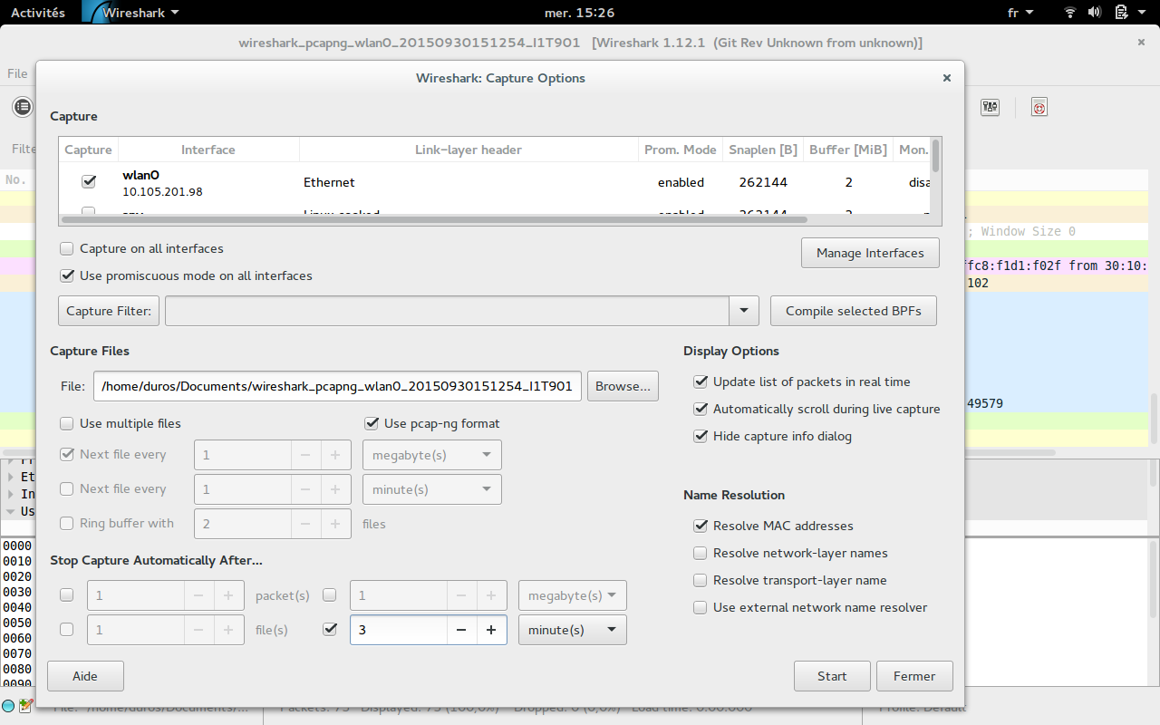
- The document « tcpdump.pdf » describes the capture filters syntax of « Tcpdump » and « Wireshark ». Create a filter (“only ICMP” and “only @IP of your host”) and analyses a ICMP exchange between you and an other host. What is the filter?
ip.src_host==10.105.201.98 and icmp

- Analyze the ARP protocol? What is its role?
Role: Obtenir une adresse MAC a partir d'une adresse IP
analyse :10.105.0.1 IntelCor_2f:1e:ac ARP 56 Who has 10.105.201.98? Tell 10.105.0.1
IntelCor_2f:1e:ac 10.105.0.1 ARP 42 10.105.201.98 is at 00:27:10:2f:1e:ac

- Send an ICMP paquet (ping) to a host on the WAN. What equipment belongs the MAC address of the received frames?

- Compare ICMP packets from a Linux system and from a Windows one. What is the difference ? How can you use-that?
Taille d'un champ data d'un icmp linux: 56bytes
sous windows: 32bytes donc la taille totale du paquet diffère: 98bytes sous linux, 74 sous windows
On peut utilise sa pour ce faire passer pour un utilisateur windows si on est sous linux et vice-versa.

- What is the standard size of an Ethernet frame (MTU) ? What does it expect if you send a frame bigger than the MTU ? Test it with ping options. Use this option to send “hidden data” in a ICMP packet to an other host ?
Standard size: 1518
Si le MTU > 1518 la trame est fragmenté.
Ping -s “taille en bytes” -p “pattern en hexa” “ip de l'host”

- Find the kernel parameter (in « /proc » filesystem) which disable ICMP reply message of your TCP-IP stack. Test it. If you know it, do the same thing with a rule of the firewall “netfilter” (will be seen in the next course).
Il faut mettre un 1 dans le fichier:
/proc/sys/net/ipv4/icmp_echo_ignore_all

- Use “arping” to bypass the behaviour of ICMP filter. What's the limitation of “arping” compared with “ping”.
Arping ne ce limite qu'au même sous-réseau. La source et la destination doivent être sur le même sous-réseau

- In text mode, display your ARP cache in a permanent way (command « watch arp -na » or « watch cat /proc/net/arp »). What is the main goal of this cache? How long does an entry stay in cache for Linux and for Windows. How a pirate could exploit that? Think about counter-measures.
Le cache est une table de couple IPV4 et adresse MAC.
Linux:
Windows:
un pirate peut envoyé une multitude de requête arp en faisant croire qu'il est quelqu'un d'autre. Le but est de ce placé entre les deux machine afin de capturer tout le trafic. Une contre mesure serait d'écrire la table en statique. Cependant cela serait trop lourd pour les gros réseaux.
- Use a web browser to connect to a web site. Analyses the first HTTP packets to find the information about your web browser and your system. Find a way to anonymize these information (browser modules or other web-browsers). Verify with “Wireshark” and write your solution for the correction.

- Display the first 3 network frames sent by a Windows system configured in static IP, during the boot time. How a pirate can exploit that ? Is-it the same under Linux? How can you avoid this béhaviour?

- Write here an explanation of the two FTP modes (passive and active). You can installed « pure-ftpd » as a FTP server. You can use « lftp » or a graphical application as client (ie. filezilla). Use screen captures of your Wireshark to explain how client and server manage together the « data port » to use in each mode. Why the active mode can't be use when you on your domestic LAN behind the ISP router (Box)? What is the only FTP mode in Firefox?

« Wireshark » advanced
Objective : Know how to exploit a capture file (.cap) in order to write a detail report.
- Retrieve the file « capture1.cap » and analyze it.
  - What is the command used by 172.16.0.10. What is the utility of the frames N°1 & 2
La commande utilisée par 172.16.0.10: arping -I XXX 172.16.70.100
Les frames 1 et 2 permettent a 172.16.0.10 d'obtenir l'adresse MAC de 172.16.70.100.

  - After almost 8 seconds (frames N°5 & 6), the command used by 172.16.0.10 is already done. Why can't we find the same ARP frames? And after 22 seconds (frame N°9)?
L'adresse MAC associer a l'adresse ip 172.16.70.100 est toujours en mémoire cache au bout de 8 seconde mais elle n'y est plus au moment du second appelle a l'arp

- Retrieve the file « capture2.cap » and analyze it.
  - What is the host 172.16.13.37 doing? What is the target?
L'utilisateur est en train de scanner les port TCP afin de déterminer quelles port peuvent être ouvert.
La cible : 172.16.70.100

  - Write a display filter to list only open ports of the target. How many ports are open?
tcp.connection.syn
1 seul port est ouvert.

- Retrieve the file « capture3.cap » and analyze it. What is this capture? What is DNS name of the server and what is its banner? Who is the sender and the recipient? Translate the message object in English. Use the function “follow tcp stream” at the beginning of the transaction (handshaking). Look at the display filter generated.
Il s'agit d'un echange par email (protocole smtp).
DNS name of server: mail.public.fr
DNS banner: ESMTP
Sender:user1@public.fr
Recipient: admin@public.fr
Message objet: Did you know it ? Le saviez vous ?

L'écran générer nous permet de lire l'email.
220 mail.public.fr ESMTP
EHLO localhost.localdomain
250-hmailserver
250-SIZE
250 AUTH LOGIN
MAIL FROM:<user1@public.fr> SIZE=541
250 OK
RCPT TO:<admin@public.fr>
250 OK
DATA
354 OK, send.
From: user1@public.fr
To: admin@public.fr
Subject: Le saviez-vous ?
Date: Thu, 23 Aug 2012 09:19:04 +0200
User-Agent: KMail/1.13.5 (Linux/2.6.36.2-desktop-2mnb; KDE/4.4.5; i686; ; )
MIME-Version: 1.0
Content-Type: Text/Plain;
charset="iso-8859-1"
Content-Transfer-Encoding: quoted-printable
Message-Id: <201208230919.04134.user1@public.fr>

Une =E9tude vient de r=E9v=E9ler qu'il n'y a que deux sortes d'administrate=
urs UNIX:
=2D ceux qui ont fait une grosse connerie sous root;
=2D ceux qui vont en faire une.
.
250 Queued (0.000 seconds)
QUIT
221 goodbye

- Retrieve the file « capture4.cap » and analyze it.
  - What is 172.16.70.99 doing? What do you think about the banner of the server? Which user account? Which password? How many messages in the letterbox? Who is the sender of the first Email? Display the attached file of the first message. Translate the second message. Isn't it true?

- How can you secure this communication. What are the different security solutions provide by your ISP? How APOP?

- Retrieve the file « capture5.cap » and analyze it. Explain how this protocol works? What is the lease time? What is its value here. Is there an other information?
Le client découvre l'adresse du DHCP via un broadcast, puis demande au DHCP une adresse IP que le DHCP lui renvoie pour un délai de 10J 3h : 874800s
autre information : renouvellement d'adresse au bout de 5J 1h30.

- Retrieve the file « capture6.cap ». Use the IO-graph function to display on the same graph : the total traffic and in different colors : the TCP flows, the SMB flows and flows of the host “208.96.2.251”. What is this host doing?

- Retrieve the file « capture7.cap » and analyze it. What do you think about that?

- Retrieve the file « capture8.cap » and analyze it. It's a bonus analyze
  - Which systems (i.e. IP addresses) are involved?
  - What can you find out about the attacking host (e.g., where is it located)?
  - How many TCP sessions are contained in the dump file?
  - How long did it take to perform the attack?
  - Which operating system was targeted by the attack? And which service? Which vulnerability?
  - Can you sketch an overview of the general actions performed by the attacker?
  - What specific vulnerability was attacked?
  - What actions does the shellcode perform? Pls list the shellcode.
  - Do you think a Honeypot was used to pose as a vulnerable victim? Why?
  - Was there malware involved? Whats the name of the malware? (We are not looking for a detailed malware analysis for this challenge)
  - Do you think this is a manual or an automated attack? Why?

